**Excel Assignment - 6**

**Q1: What are the various elements of the Excel interface? Describe how they're used.**

Ans: menu bar and contain a File, Insert, Page Layout, Formulas, Data, Review, View, Help, and a Search Bar with a light bulb icon , sheet contain cells .

**Q2: Write down the various applications of Excel in the industry.**

Ans: There are various applications of excel such as : s

1. Account Management : include budget plan , forecasts , financial report , loan calculators .
2. Strategic Analysis: Spreadsheet analysis is designed to inform business decisions in a specific way.
3. **Business Analysis : Analysis is the activity of converting data into something useful to the people who run the business.**
4. People Management : Using Excel, information about an individual person can be stored and retrieved efficiently.
5. Office administration : supporting day-to-day tasks such as invoicing, paying bills, and contacting suppliers and clients.

**Q3 On the ribbon, make a new tab. Add some different groups, insert commands in the groups and name them according to their commands added. Copy and paste the screenshot of the steps you followed.**

Ans: Step 1: Right click on ribbon and choose Customise the ribbon .

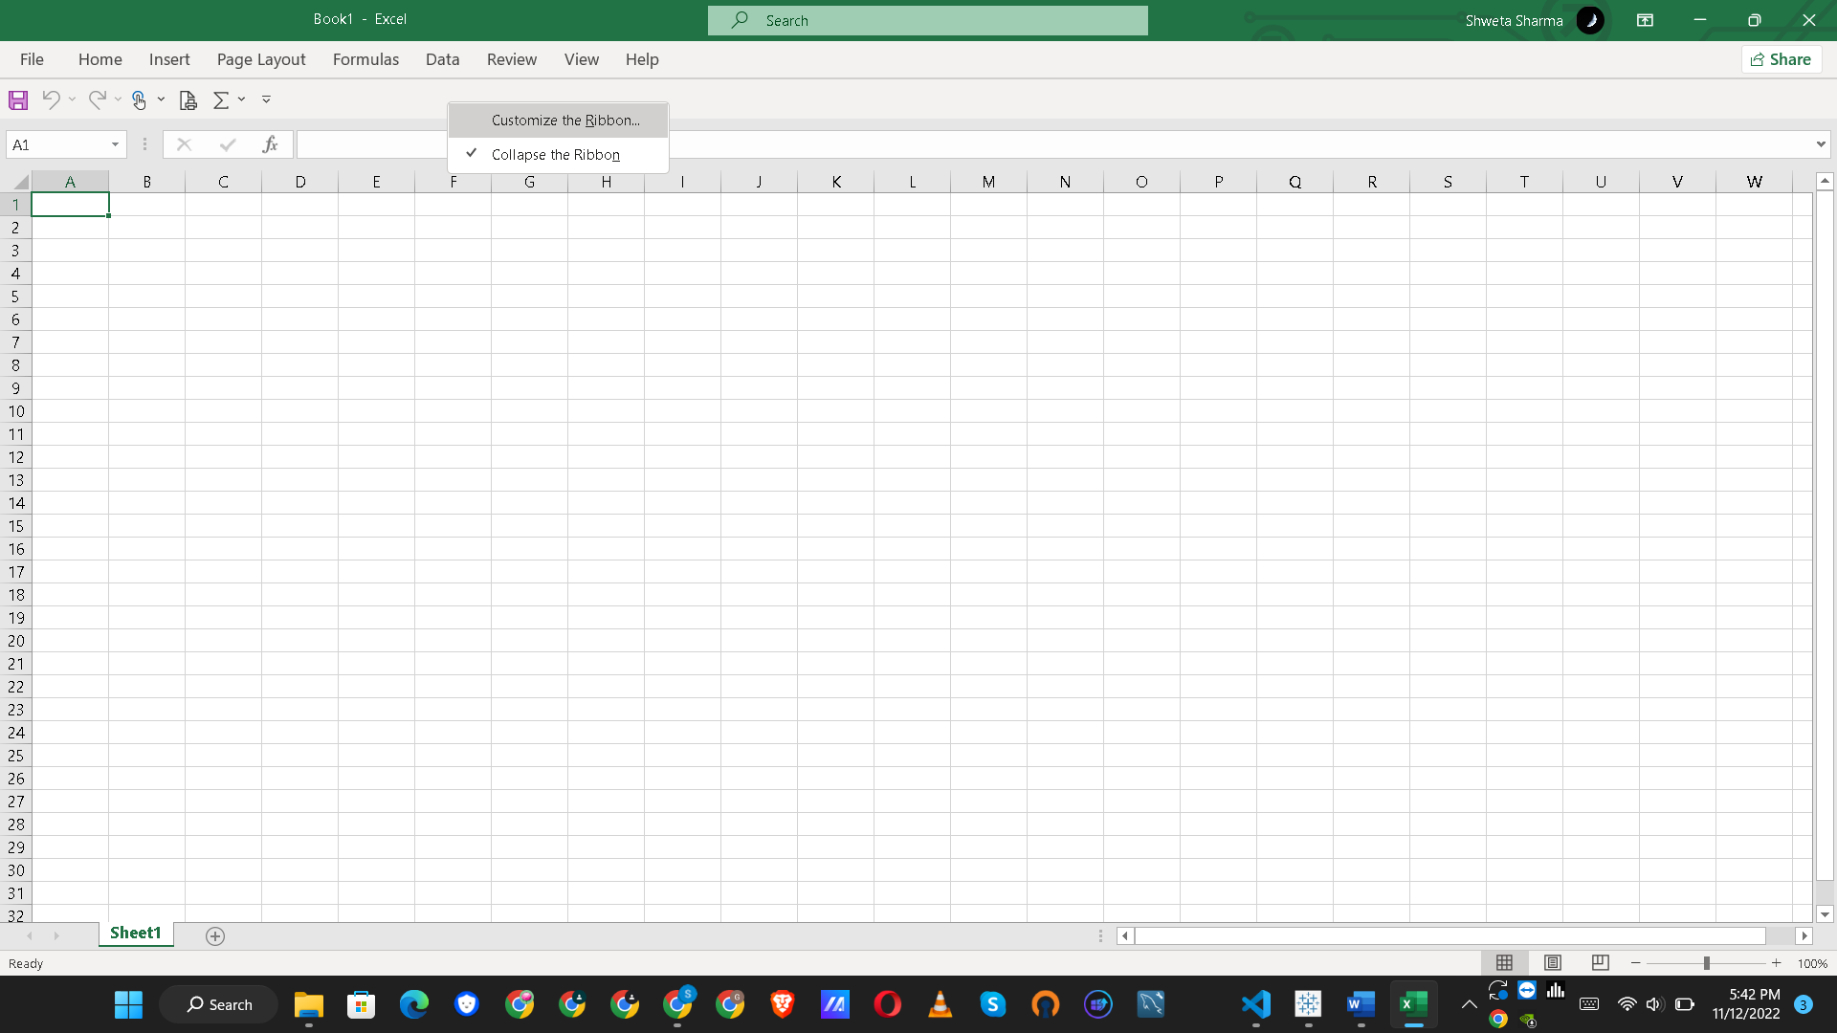

Step 2: You can see the excel options .Choose the tab after which you want to add custom tab .

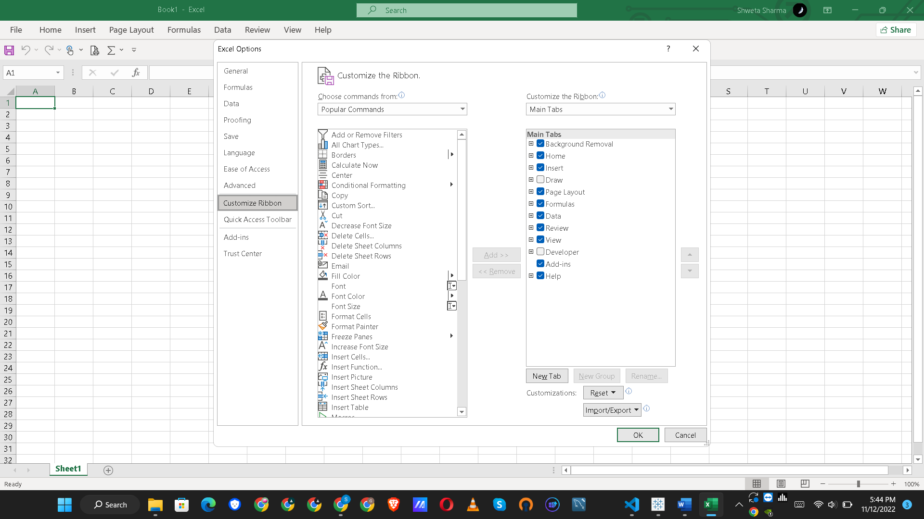

Step 3: After selecting review tab , click on new tab .

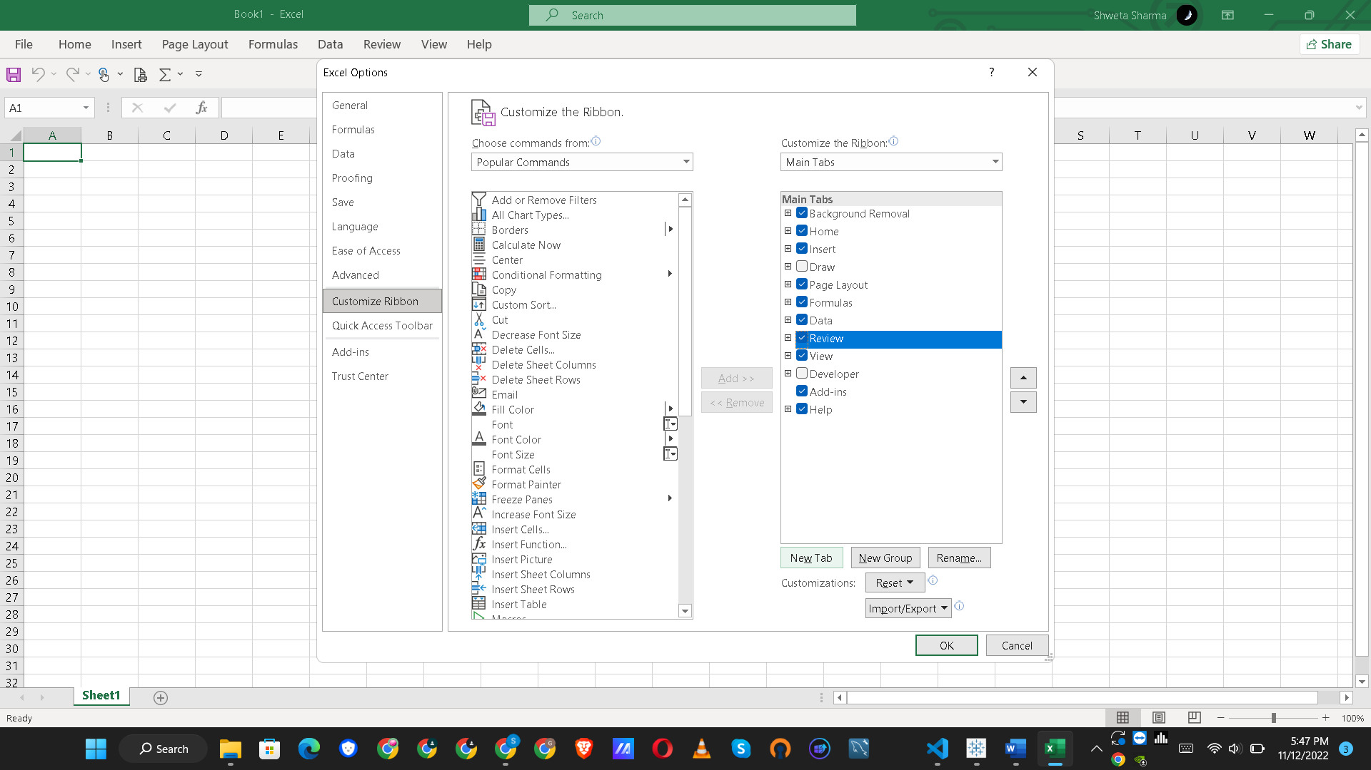

Step 4: New custom tab is created after review tab . Rgiht click and rename it.

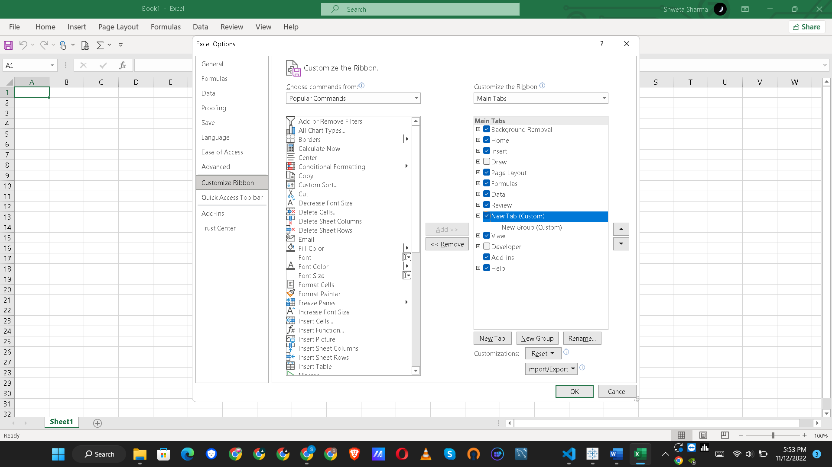

Step 5 : After rename the new tab , rename the new group as txt format and you can also create more groups as example I have created one more group as ‘text color and size’ .And then click on OK .

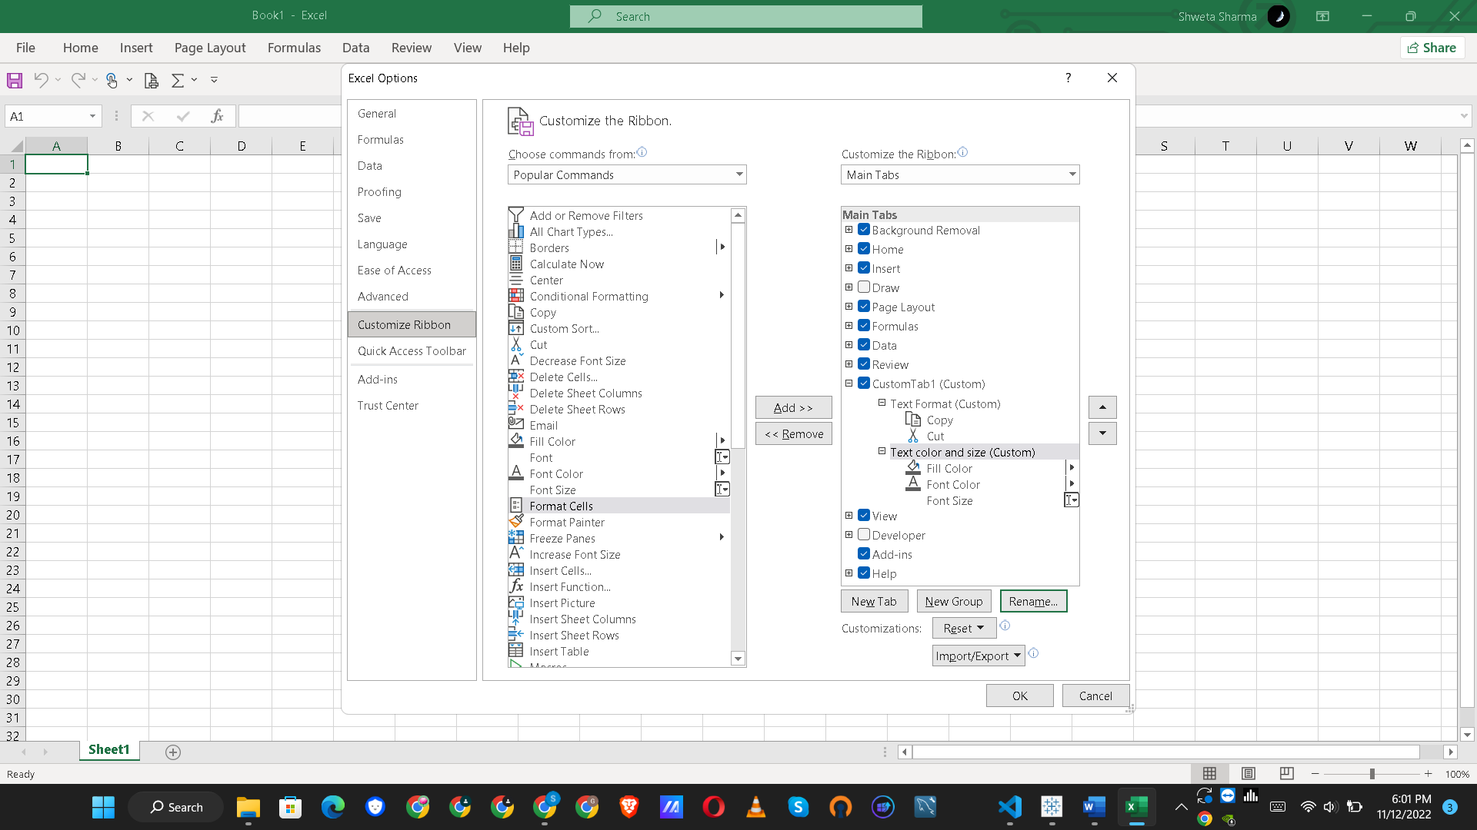

Step 5 : You can see the custom tab 1 after review tab .On click we can see the two groups which hass been created.

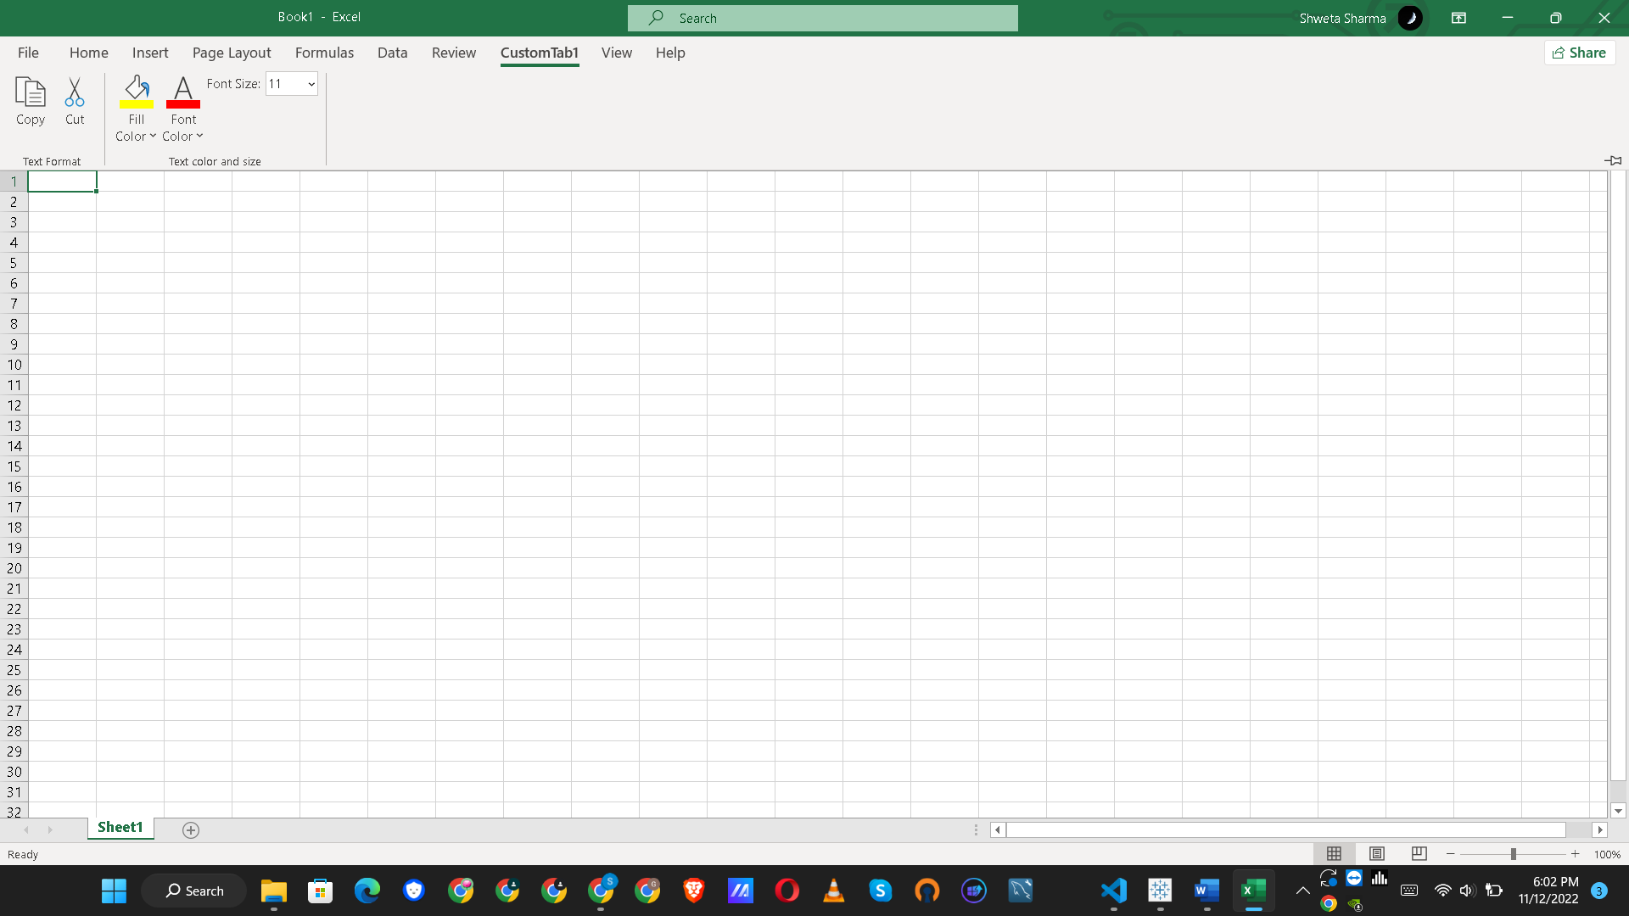

**Q4: Make a list of different shortcut keys that are only connected to formatting with their functions.**

Ans: 1. Open the Format Cells dialog box. : Ctrl +1

2. Format fonts in the Format Cells dialog box. : Ctrl+Shift+F or Ctrl+Shift+P

3. Insert a note. : Shift+F2

4. Open the Insert dialog box to insert blank cells. :Ctrl + Shift + Plus sign (+)

5. Open the Delete dialog box to delete selected cells. : Ctrl+Minus sign (-)

6 . Enter the current time. : Ctrl+Shift+Colon (:)

7. Enter the current date. : Ctrl+Semicolon (;)

9. Copy a formula from the cell above the active cell into the cell or the formula bar. : Ctrl+Apostrophe (')

10. Move the selected cells. : Ctrl+X

11. Copy the selected cells. : Ctrl+C

12. Paste content at the insertion point, replacing any selection. : Ctrl+V

13. Open the Paste Special dialog box. : Ctrl+Alt+V

14. Italicize text or remove italic formatting. : Ctrl+I or Ctrl+3

15. Bold text or remove bold formatting. : Ctrl+B or Ctrl+2

16. Underline text or remove underline. : Ctrl+U or Ctrl+4

18. Apply an outline border to the selected cells. : Ctrl+Shift+Ampersand sign (&)

19. Remove the outline border from the selected cells. : Ctrl+Shift+Underscore (_)

20. Display or hide the outline symbols. : Ctrl+8

21. Use the Fill Down command to copy the contents and format of the topmost cell of a selected range into the cells below. : Ctrl+D

23. Apply the Currency format with two decimal places (negative numbers in parentheses). : Ctrl+Shift+Dollar sign ($)

24. Apply the Percentage format with no decimal places. : Ctrl+Shift+Percent sign (%)

25. Apply the Scientific number format with two decimal places. : Ctrl+Shift+Caret sign (^)

26. Apply the Date format with the day, month, and year. : Ctrl+Shift+Number sign (#)

27. Apply the Time format with the hour and minute, and AM or PM. : Ctrl+Shift+At sign (@)

28. Apply the Number format with two decimal places, thousands separator, and minus sign (-) for negative values. : Ctrl+Shift+Exclamation point (!)

29. Open the Insert hyperlink dialog box. : Ctrl+K

30. Check spelling in the active worksheet or selected range. : F7

32. Display the Create Table dialog box. : Ctrl+L or Ctrl+T

33. Open the Workbook Statistics dialog box. : Ctrl+Shift+G

**Q5: What distinguishes Excel from other analytical tools?**

Ans: Alt H+M+M

**Q6** **Create a table and add a custom header and footer to your table.**

Ans: =TEXT(Value you want to format, "Format code you want to apply")